Semester Project

Husnain Sattar
23F-0560
Sawan Masih
23F-0533

Student Management System

Fast National University
Code:
#!/bin/bash
data="data.txt"
pass="123"
if [ ! -f "$data" ]; then
touch "$data"
fi
login() {
echo -n "Password= "
read input
if [ "$input" == "$pass" ]; then
menu
else
echo "Wrong password"
fi
}
menu() {
while true; do
echo "1 Add"
echo "2 View"
echo "3 Edit"
echo "4 Delete"
echo "5 List"
echo "6 Stu Login"
echo "7 Quit"
read -p "Pick= " opt
case $opt in
1) add ;;
2) view ;;
3) edit ;;
4) del ;;
5) list ;;
6) slogin ;;
7) break ;;
*) echo "wrong input" ;;
esac
done
}
add() {
count=$(wc -l < "$data")
if [ "$count" -ge 20 ]; then
echo "Max limit reached"
return
fi
read -p "ID= " id
grep -q "^$id," "$data" && echo "ID exists" && return
read -p "Name= " name
read -p "Marks= " marks
if [ "$marks" -ge 90 ]; then
grade="A"
cgpa="4.0"
elif [ "$marks" -ge 80 ]; then
grade="B"
cgpa="3.0"
elif [ "$marks" -ge 70 ]; then
grade="C"
cgpa="2.0"
elif [ "$marks" -ge 60 ]; then
grade="D"
cgpa="1.0"
else
grade="F"
cgpa="0.0"
fi
echo "$id,$name,$marks,$grade,$cgpa" >> "$data"
echo "Added"
}
view() {
read -p "Enter ID= " id
line=$(grep "^$id," "$data")
if [ -z "$line" ]; then
echo "No data"
else
IFS=',' read -r i n m g c <<< "$line"
echo "ID= $i"
echo "Name= $n"
echo "Marks= $m"
echo "Grade= $g"
echo "CGPA= $c"
fi
}
edit() {
read -p "ID to edit= " id
line=$(grep "^$id," "$data")
if [ -z "$line" ]; then
echo "Not found"
return
fi
read -p "New Marks= " marks
name=$(echo "$line" | cut -d',' -f2)
# assign grade and CGPA based on marks
if [ "$marks" -ge 90 ]; then
grade="A"
cgpa="4.0"
elif [ "$marks" -ge 80 ]; then
grade="B"
cgpa="3.0"
elif [ "$marks" -ge 70 ]; then
grade="C"
cgpa="2.0"
elif [ "$marks" -ge 60 ]; then
grade="D"
cgpa="1.0"
else
grade="F"
cgpa="0.0"
fi
echo "$id,$name,$marks,$grade,$cgpa" >> temp.txt
grep -v "^$id," "$data" > temp2.txt
cat temp.txt >> temp2.txt
mv temp2.txt "$data"
rm temp.txt
echo "Updated"
}
del() {
read -p "ID to delete= " id
grep -v "^$id," "$data" > temp.txt && mv temp.txt "$data"
echo "Deleted"
}
list() {
echo "1= Passed"
echo "2= Failed"
echo "3= Asc"
echo "4= Desc"
read -p "Pick= " x
case $x in
1) awk -F',' '$5 >= 2.0 {print $0}' "$data" ;;
2) awk -F',' '$5 < 2.0 {print $0}' "$data" ;;
3) sort -t',' -k5 -n "$data" ;;
4) sort -t',' -k5 -nr "$data" ;;
*) echo "Bad input" ;;
esac
}
slogin() {
read -p "ID= " id
line=$(grep "^$id," "$data")
if [ -z "$line" ]; then
echo "No record"
return
fi
IFS=',' read -r i n m g c <<< "$line"
echo "Welcome $n"
echo "Marks= $m"
echo "Grade= $g"
echo "CGPA= $c"
}
login

Output :
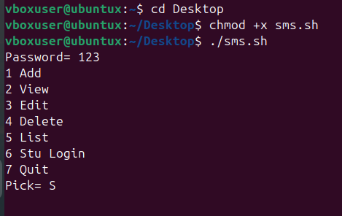

Option 1
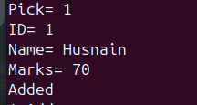
Option 2
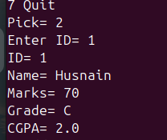
Option 3
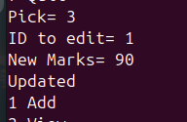
Option 4
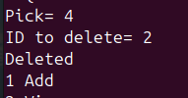
Option 5
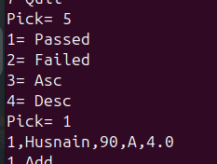
Option 6
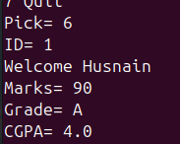
Option 7


